Phase 3 Report — Host Hardening + Detection (UFW + Fail2ban)
Date: 2025-12-20

1. Objective
This phase demonstrates practical defensive controls: (1) pfSense firewall logging for visibility, (2) Ubuntu DMZ hardening with UFW, and (3) detection/response against SSH brute-force attempts using Fail2ban.

2. Lab Topology
The lab uses pfSense to segment a LAN and a DMZ. Kali generates test traffic and Ubuntu hosts services in the DMZ.
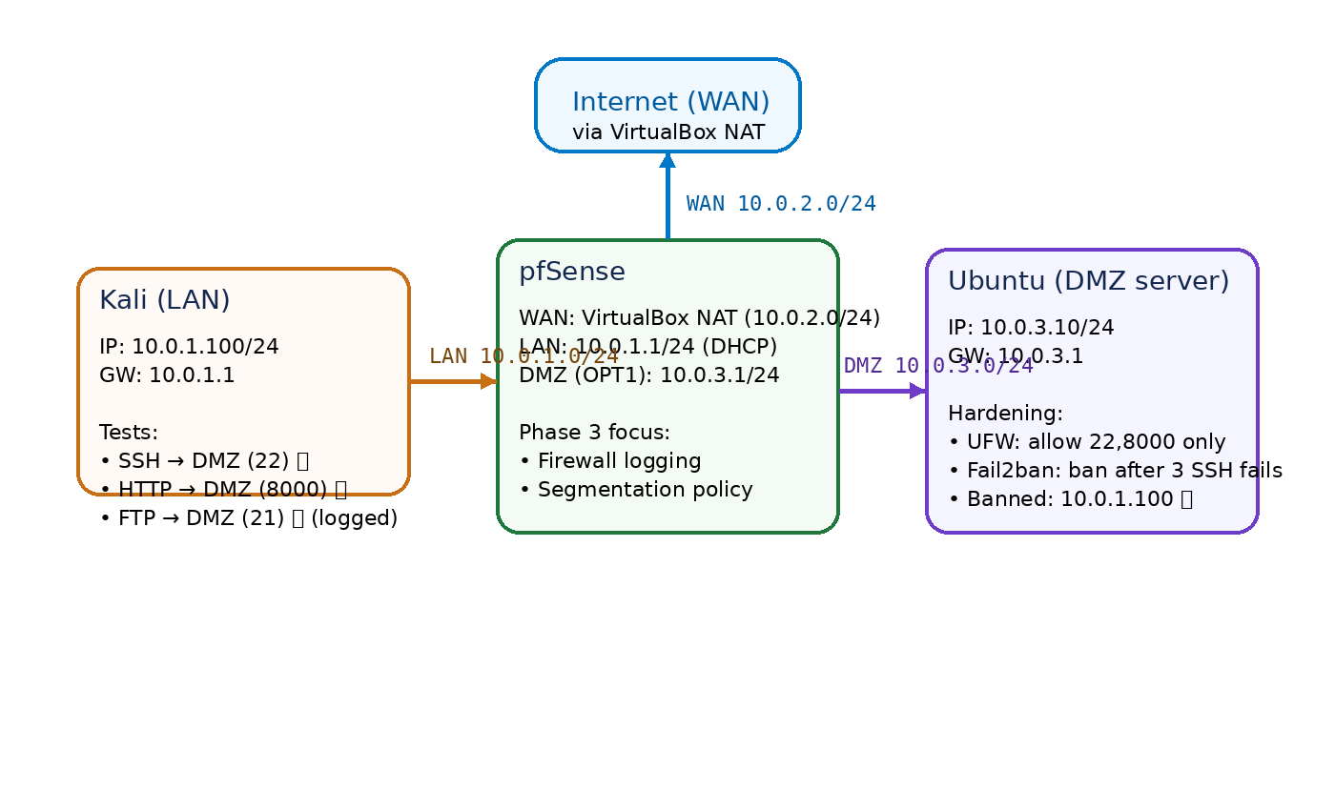
Figure 1. Phase 3 lab topology (pfSense + LAN + DMZ).

3. Key Fix: Removing Subnet Collision
The DMZ was initially configured as 10.0.2.0/24, which conflicted with pfSense WAN (VirtualBox NAT uses 10.0.2.0/24). This created ambiguous routing. The DMZ was moved to 10.0.3.0/24, restoring correct connectivity.

4. pfSense: Firewall Logging Evidence
Logging was enabled on the LAN→DMZ block rule. A blocked connection attempt (FTP/21) from Kali to the DMZ server was used as evidence.
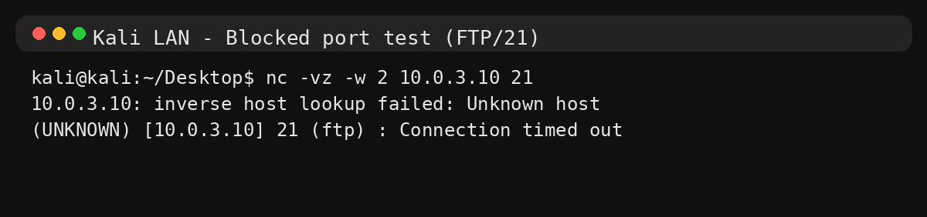
Figure 2. Kali attempting FTP/21 to the DMZ server (expected timeout).
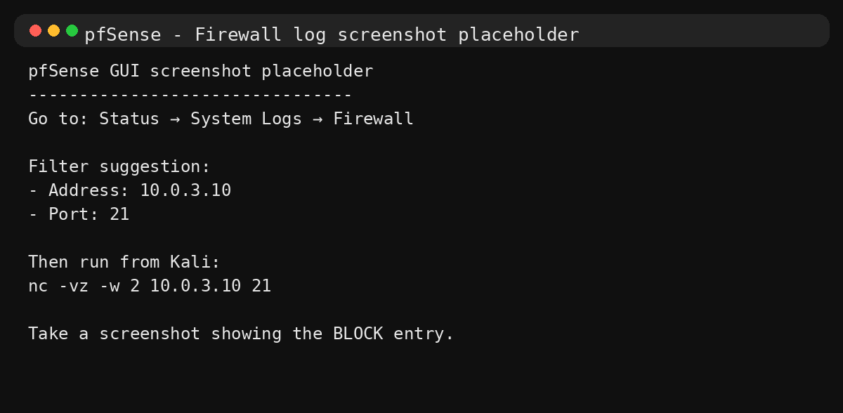
Figure 3. Placeholder — insert pfSense firewall log screenshot showing the blocked port 21 entry.

5. Ubuntu DMZ: Host Hardening with UFW
UFW was enabled on the Ubuntu DMZ server with a default-deny incoming policy. Only SSH (22/tcp) and the lab HTTP service (8000/tcp) were allowed.
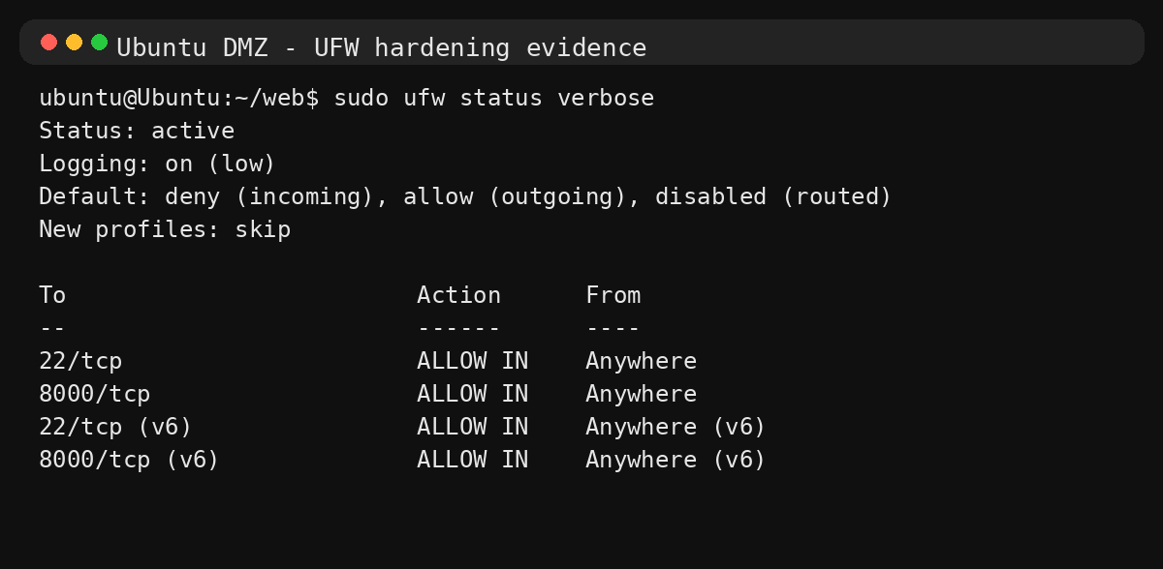
Figure 4. UFW status (default deny incoming, allow 22 and 8000).

6. Ubuntu DMZ: Detection & Response with Fail2ban
Fail2ban was configured for sshd. After three failed SSH logins, the attacking IP is banned temporarily.
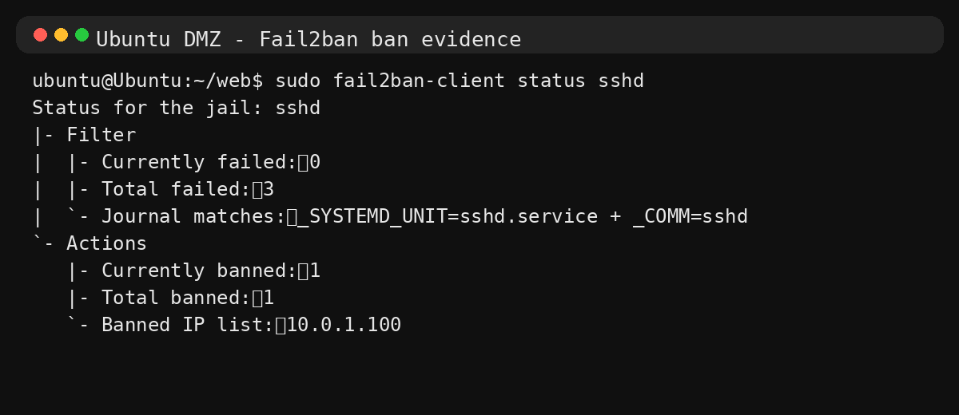
Figure 5. Fail2ban sshd jail showing the banned IP (10.0.1.100).

7. Segmentation Proof: DMZ → LAN Blocked
An ICMP test from DMZ to LAN was blocked, demonstrating the DMZ cannot initiate traffic into the LAN.
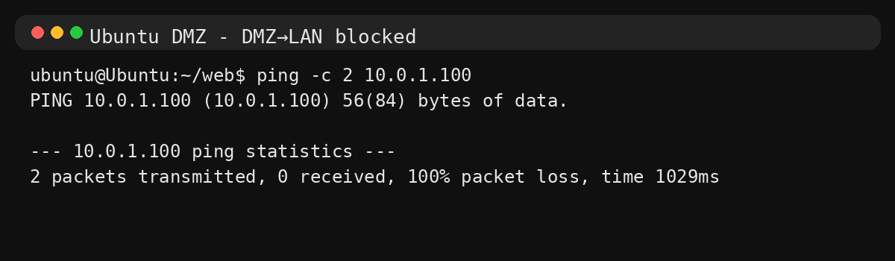
Figure 6. DMZ → LAN ping blocked (100% loss).

8. Conclusion
Phase 3 confirms defense-in-depth in the lab: pfSense provides segmentation and logging, UFW limits exposed services on the DMZ server, and Fail2ban adds automated detection and response against brute-force behavior.

